Rev. Walden Pell II
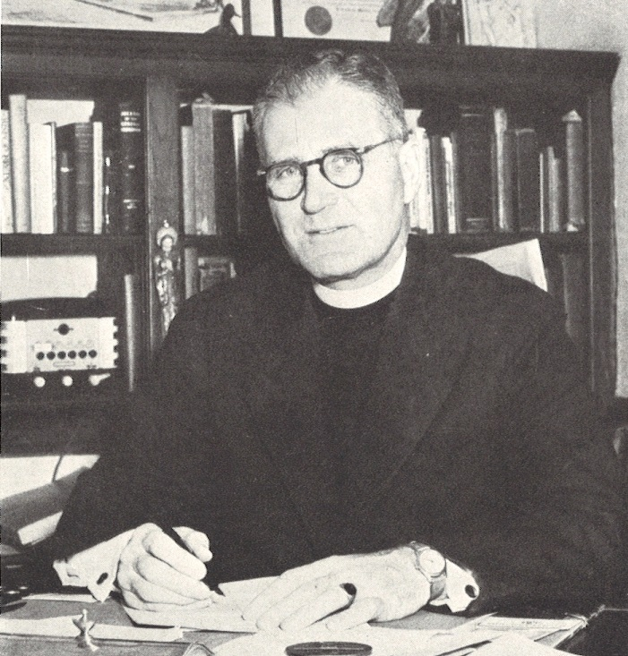

Walden "Waldy" Pell II was the first headmaster of St. Andrew's School arriving in 1929 at the age of 27 and remained until 1957. Rev. Pell attended Princeton, Oxford University and later Union Theological Seminary, Columbia University. He was ordained a deacon of the Episcopal Church in 1927 and a priest in 1928. Prior to being headmaster, he was a master at The Lenox School in Lenox, Massachusetts for three years. Walden suggested the name of the School, St. Andrew's, chose the School colors, red and white (on his first visit to campus with founders Felix duPont and Alan Henry, he saw a male cardinal in the bushes) and hired the first faculty. Besides the daunting task of running the School, he taught Sacred Studies, chaired the Vestry committee and coached baseball and intramural crew.
He married his wife Edith in 1927 and they lived primarily in the Headmaster's house. Walden and Edith had three children, daughters Melissa (Missy) and Mary Leigh (Lili) and one son, Stuyvesant. Such a small community at the time, the Pell family were deeply embedded in the lives of the students, the faculty and the staff.
Rev. Pell authored "The Religion of the Prayer Book" and compiler for "A History of St. Andrew's School at Middletown, Delaware, The First Thirty Years."
A deeply religious man, he served at St. Peter's Church, Singapore from 1958 to 1960; he was the priest in charge in the Mekong Missionary district in Cambodia and Laos in the early 1960s and the Augustine Parish, Chesapeake City, Maryland from 1963 to 1968. Walden and Edith lived in a home on the Elk River in Elkton, Maryland naming it "Perfect End".
There is a small garden in historic south Chesapeake City, Maryland named Pell Gardens as a tribute to Waldy after being named Outstanding Citizen of the Year by the Cecil County Chamber of Commerce in 1972.
After a short bout with cancer, Rev. Pell died in 1983 at the age of 80.
Pell Hall, located next to the library in Founders', named in 1984, houses III form girls.

